The Grove Road Curriculum

Thematic Learning & Topic Webs

Across each phase of school, teachers use a thematic approach to planning, putting together half-termly/termly topic webs that advocate creativity, cross-curricular learning and active engagement (refer to the example topic web below).
Each topic web is centred around a theme or topic that teachers believe will attract their pupils’ imaginations and interests, creating a ‘way in’ for various areas of the curriculum. Topic webs incorporate a ‘Stunning Start’ and ‘Fabulous Finish’. A ‘Stunning Start’ is a launch event that engages children in their learning; a focal point for the sequence of teaching that leads to multiple learning opportunities and avenues for investigation, such as a visit to a castle, a special visitor or an archaeological dig. A ‘Fabulous Finish’ is a ‘finale’ to a sequence of learning that creates purpose to the children’s learning, such as a performance assembly where visitors are invited, writing to the Prime Minister or running a campaign to raise money for the World Wildlife Fund in order to protect wild animals.
Creativity and fun in planning for learning is a priority to ensure learning is enjoyable, active and challenging. The Social, Moral, Spiritual and Cultural aspects of learning are taken into account ensuring teaching reflects and celebrates our cultural diversity as a school.
The curriculum model encourages pupils to make discoveries, to be excited and to want to find out more. Learning will be personalised and achievements recognised and celebrated. The emphasis is on the development of skills and understanding and on encouraging learners to investigate and expand their subject knowledge through a range of activities designed for the individual.

Metacognition & the ReflectED approach

We are a lead ‘hub’ school for ReflectED, which is an approach to learning developed by Rosendale Research School in London. The approach, which is used throughout our curriculum, teaches and develops our children’s metacognition skills (learning how they learn). It supports and improves attainment, especially amongst disadvantaged pupils, and aims to help learners of all backgrounds develop the tools to make excellent progress in their learning and fulfil their potential.
ReflectED teaches children the skills of reflection and how to record their learning moments and strategies. Teachers can also look across these reflections to understand what pupils are enjoying or struggling with, and identify specific pupil needs.
Evidence suggests the metacognitive skills children develop through ReflectED will significantly enhance their learning.

How it works

Each class in school receives a weekly ‘metacognition’ lesson. The children learn new skills, such as how to juggle, how to use chopsticks, how to tie shoelaces etc. The purpose of these skills lessons is to teach children a new skill which they will most likely find difficult and challenging. We purposefully put the children in a position in which they feel ‘stuck’. Subsequent lessons deliver key messages around ‘having a growth mind-set’, what makes a successful learner, cognition and metacognition, being in ‘The Learning Pit’ and possessing skills of resilience, grit and determination in order to succeed.

Throughout the school day, staff support children to make ‘reflections’ about their learning. They discuss what has helped them to be successful with a specific learning task and use colour tags to represent how confident they are feeling. Red means they feel stuck , and need to be resilient and find strategies to help them. Yellow means they are getting there, but need to continue to be determined in order to become more confident. Green means they feel confident, and with a little more hard work will become masters of a particular task. Blue means that the children feel so confident about a task that they can ‘coach’ and support a partner to learn. Blue learners are ready to seek additional challenge so that they are stretching themselves to achieve more.

All staff incorporate the language learned in the metacognition skills lessons across all subject areas, so that the strategies learnt through embracing the ‘struggle’ of learning a new skill creates a crucial learning point for children and equips them with values of resilience, determination and grit that help them succeed across the curriculum.
The culture of metacognitive language for learning, modelled by staff, is what supports our children’s own ‘growth-mindsets’, giving them the determination and belief required to be successful.

On a daily basis, children and staff use Seesaw to share new learning. Children’s learning is shared on Seesaw so that parents can see, ‘like’ and ‘comment’ on their child’s work. Seesaw is also used by children to make reflections; they share ‘marvellous mistakes’ which they’ve learned from and they discuss how they have found an activity/lesson.

Across the Grove Road Curriculum, we promote and explicitly praise our children for making and learning from ‘marvellous mistakes’. We embrace a culture where making mistakes is part of life; we are accepting of and positive about each other’s mistakes because we realise that mistakes and being ‘stuck’ are the best opportunities we have to learn. By creating a school environment where ‘feeling red’ and learning from mistakes is embraced, we aim for Grove Road children to intrepid and bold, undaunted by failure; instilling life-long skills and values that we see as fundamental to their futures.

Grove Road as a lead school for metacognition – would you like to get involved?
In collaboration with Rosendale Research School, we are a lead school for the ReflectED approach, training other schools in how to embed a metacognitive approach to teaching and learning.
Teachers can access to a wide range of supporting materials on the ReflectED website, including films and downloads. Face to face training is available to schools who are new to ReflectED and want additional support. Contact our school office to find out more.

Developing Oracy and Language Skills

Developing our children’s language skills and oracy is the number one priority at Grove Road. We see the skills of communication as one of the keys that will unlock the potential of all our learners, preparing them for successful and happy futures.
Research indicates that children’s vocabulary development directly impacts upon their future success in education and into adulthood. Reading is at the heart of this, as is engaging children in conversation and modelling good use of language so that their vocabularies develop. The use of ‘sentence stems’ to support our children’s classroom talk is an important part of how our Grove Road staff model language to the children.

Examples of sentence stems currently used in Science lessons:
‘I predict that_________ because________.’
‘We want to test ________ to find out whether _______.’
‘The similarities/differences between __________ and ________ are ________. ‘

To find out more about stem sentences, click here.
We’d like to share with you a short piece from the Oxford Language Report, a research study looking at the importance of children’s language development:
‘… the size of a child’s vocabulary is the best predictor of future success, and children with a poor vocabulary at five years old are four times more likely to struggle with reading in adulthood and three times more likely to have mental health issues.’

Kagan Cooperative Learning Structures
One of the ways we incorporate the promotion of ‘talk’ across the curriculum, is through Kagan Cooperative Learning Structures. Kagan Structures are classroom strategies which improve children’s social skills and relationship skills by promoting and facilitating quality discussion during lessons.
Cooperative learning theory suggests that students learn best when they can encourage and ‘coach’ each other, when they are held individually accountable, when they all participate equally, and when there is a great deal of active, interactive engagement. Kagan group work usually produces very equal participation as the activities cause children to take turns and share information, and often includes individual accountability, a dimension proven to be essential for producing consistent achievement gains for all children.
Two examples of a Kagan Structures:

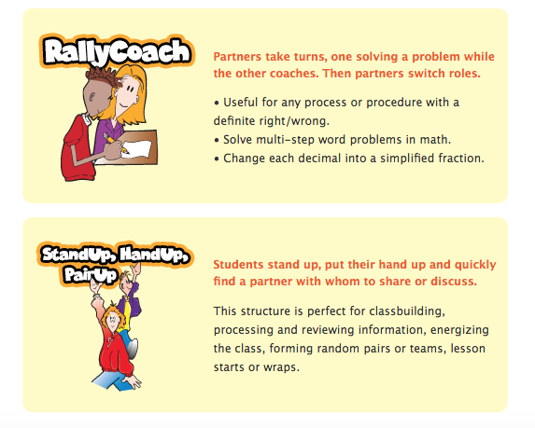

Topic web example

